DEEP LEARNING IMAGE CLASSIFICATION PROJECT

Title
- Deep Learning Image Classification Project using Transfer Learning

Objective
- To build an image classification model using deep learning and transfer learning to classify images of cats and dogs.

Dataset
- The dataset used is the cats vs dogs dataset from Tensor Flow Datasets. It contains labeled images of cats and dogs for binary classification.

Data Preprocessing
- Images were resized to 160 by 160 pixels.
- Pixel values were normalized between 0 and 1.
- Dataset was split into training and validation sets.
- Data was batched and shuffled for training
Screenshot of image shape and label shape output
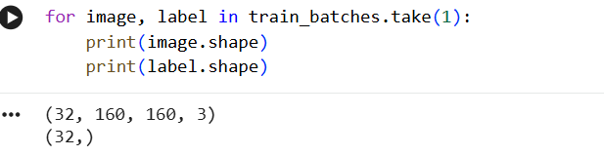

Model Architecture
- A pretrained MobileNetV2 model was used for transfer learning.
- The base model was frozen.
- Custom dense layers were added for classification
Screenshot of model summary
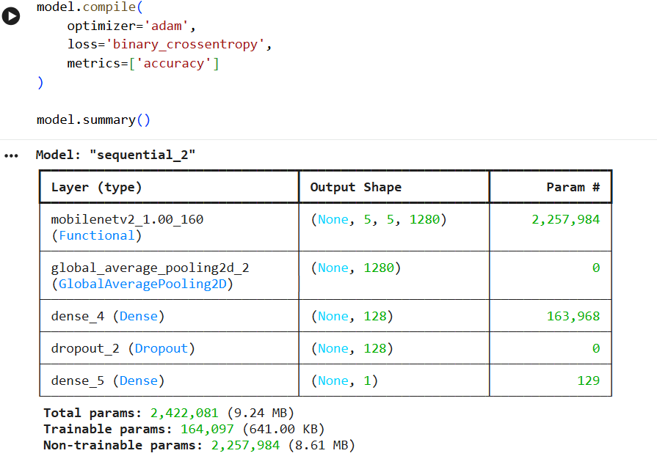

Model Training
- The model was trained for 5 epochs using the training dataset.
- Validation data was used to monitor performance
Screenshot of training accuracy and loss output
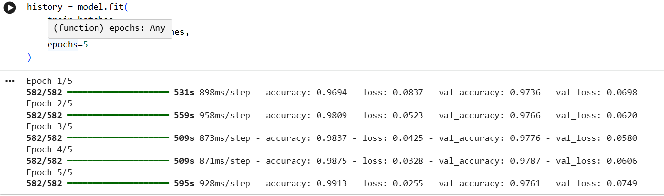

Model Evaluation
- The model was evaluated using validation accuracy.
- The model performed well in classifying cats and dogs

Prediction
- The trained model was used to predict new images
Screenshot of prediction output
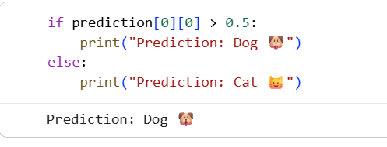

Conclusion
- The deep learning model using MobileNetV2 successfully performed image classification.
- Transfer learning helped improve accuracy and reduced training time.
- The model was able to correctly classify images of cats and dogs.

